**24th Vasaloppet China, January 4th, 2026**

**TRAVEL PACKAGES FROM ORGANIZER**

|  |  |
| --- | --- |
| **4 DAYS TRIIP**  **Vasaloppet China race & Changchun local travel** | |
| Jan. 02, 2026 | 1. Arrive in Changchun. 2. We will arrange a car to pick you up at the airport and go to your hotel. 3. Check into Hotel in Changchun. |
| Jan. 03, 2026 | 1. Have breakfast, lunch and dinner at the hotel. 2. Pick up race supplies, track test and visit【Jingyuetan Snow Sculpture World】. 3. Visit ice light show at the【New World Of Ice And Snow】. |
| Jan. 04, 2026 | 1. Have breakfast and lunch at the hotel. 2. Vasaloppet China 50km, 25km and 2km will start at the same time. 3. Have dinner at the Vasanight. |
| Jan. 05, 2026 | 1. Have breakfast at the hotel. 2. Visit landmark buildings in Changchun :   ①【Cultural Square】(Manchurian State Capital Square)  ②【Geological Palace Museum 】(Puyi Palace)   1. We will arrange a car to take you to the airport or railway station in Changchun. 2. Return trip. |

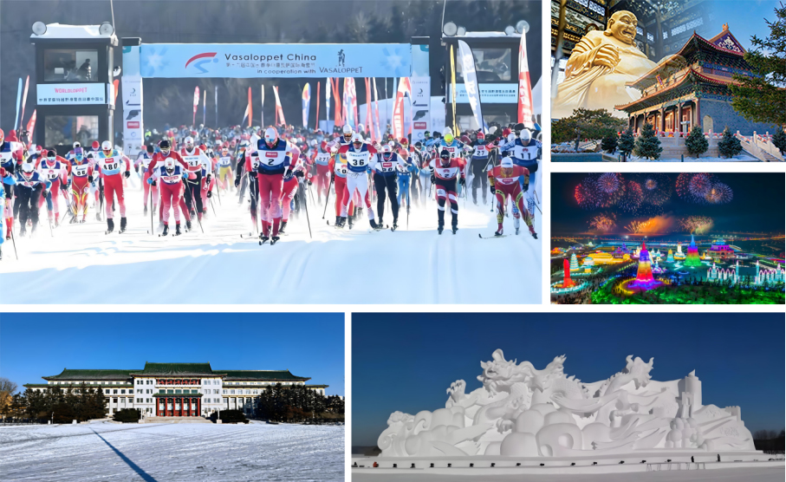

|  |  |
| --- | --- |
| **SEVEN DAYS TRIP**  **Vasaloppet China race & Changchun local travel & Beijing travel** | |
| Jan. 02, 2026 | 1. Arrive in Changchun. 2. We will arrange a car to pick you up at the airport and go to your hotel. 3. Check into Hotel in Changchun. |
| Jan. 03, 2026 | 1. Have breakfast, lunch and dinner at the hotel. 2. Pick up race supplies, track test and visit【Jingyuetan Snow Sculpture World】. 3. Visit ice light show at the【New World Of Ice And Snow】. |
| Jan. 04, 2026 | 1. Have breakfast and lunch at the hotel. 2. Vasaloppet China 50km, 25km and 2km will start at the same time. 3. Have dinner at the Vasanight. |
| Jan. 05, 2026 | 1. Have breakfast at the hotel. 2. Visit landmark buildings in Changchun :   ①【Cultural Square】(Manchurian State Capital Square)  ②【Geological Palace Museum 】(Puyi Palace)   1. Have lunch at a local restaurant. 2. Go to Beijing by high-speed railway. 3. Check into hotel in Beijing. 4. Dinner at a local restaurant. |
| Jan. 06, 2026 | 1. Have breakfast at the hotel. 2. Visit the【Forbidden City】and【Tian 'anmen Square】. 3. Have lunch at a local restaurant. 4. Visit【Qianmen】and【Temple of Heaven】 in the afternoon. 5. Peking Duck for dinner. |
| Jan. 07, 2026 | 1. Have breakfast at the hotel. 2. Visit the【Great Wall】. 3. Light meal for lunch (bread, milk, sausage). 4. Chinese dumplings/fried dumpling for dinner. |
| Jan. 08, 2026 | 1. Have breakfast at the hotel. 2. Return trip. |

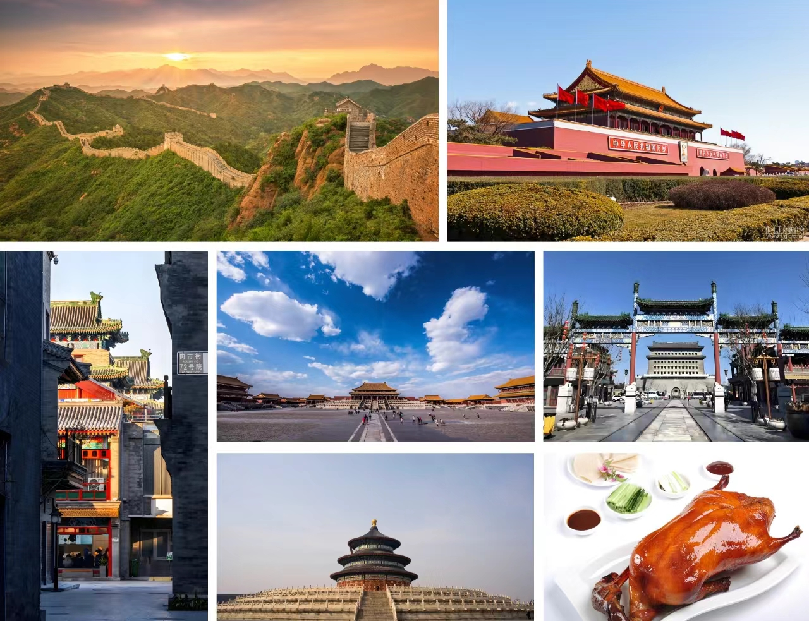

|  |  |
| --- | --- |
| **NINE DAYS TRIP**  **Vasaloppet China race & Changchun local travel & Beijing+Xi’an travel** | |
| Jan. 02, 2026 | 1. Arrive in Changchun. 2. We will arrange a car to pick you up at the airport and go to your hotel. 3. Check into Hotel in Changchun. |
| Jan. 03, 2026 | 1. Have breakfast, lunch and dinner at the hotel. 2. Pick up race supplies, track test and visit【Jingyuetan Snow Sculpture World】. 3. Visit ice light show at the【New World Of Ice And Snow】. |
| Jan. 04, 2026 | 1. Have breakfast and lunch at the hotel. 2. Vasaloppet China 50km, 25km and 2km will start at the same time. 3. Have dinner at the Vasanight. |
| Jan. 05, 2026 | 1. Have breakfast at the hotel. 2. Visit landmark buildings in Changchun :   ①【Cultural Square】(Manchurian State Capital Square)  ②【Geological Palace Museum 】(Puyi Palace)   1. Have lunch at a local restaurant. 2. Go to Beijing by high-speed railway. 3. Check into hotel in Beijing. 4. Dinner at a local restaurant. |
| Jan. 06, 2026 | 1. Have breakfast at the hotel. 2. Visit the 【Forbidden City】and【Tian 'anmen Square】. 3. Have lunch at a local restaurant. 4. Visit【Qianmen】and【Temple of Heaven】 in the afternoon. 5. Peking Duck for dinner. |
| Jan. 07, 2026 | 1. Have breakfast at the hotel. 2. Visit【Great Wall】. 3. Light meal for lunch (bread, milk, sausage). 4. Chinese dumplings/fried dumpling for dinner. |
| Jan. 08, 2026 | 1. Have breakfast at the hotel. 2. Go to Xi’an by high-speed railway. 3. Check into hotel in Xi’an. 4. Visit the【Yongxing Fang】and try local snacks. 5. Visit the【Great Tang All Day Mall】. |
| Jan. 09, 2026 | 1. Have breakfast at the hotel. 2. Visit the【Terra-cotta Warriors Museum】. 3. Have lunch at a local restaurant. 4. Visit the【Xi 'an Ancient City Wall】. 5. Visit the【Tang Le Palace】and have dinner of imitation Tang Dynasty |
| Jan. 10, 2026 | 1. Have breakfast at the hotel. 2. Back to Beijing by high-speed railway. 3. Return trip. |

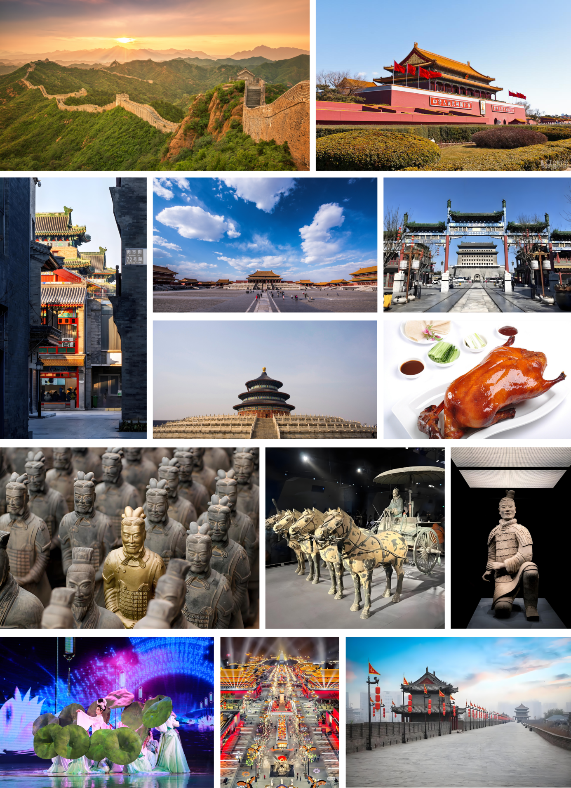

|  |  |
| --- | --- |
| **Race Category** | Type（**√**）after the option you wish to select |
| 0.3 KM: 100 CNY |  |
| 1.5 KM: 150 CNY |  |
| 6 KM: 200 CNY |  |
| 25 KM: 490 CNY |  |
| 50 KM: 750 CNY |  |
| **Package** | Type（**√**）after the option you wish to select |
| 4 DAYS: 2400 CNY |  |
| 7 DAYS: 6000 CNY |  |
| 9 DAYS: 9600 CNY |  |

|  |  |  |  |  |
| --- | --- | --- | --- | --- |
| **Hotel** | 5-Star  （single room） | 5-Star  （twin room） | 3-Star  （single room） | 3-Star  （twin room） |
| Changchun |  |  |  |  |
| Beijing |  |  |  |  |
| Xi’an |  |  |  |  |
| Select the room type and enter the required number in the corresponding location | | | | |
| **Room price** | 5-Star  （single room） | 5-Star  （twin room） | 3-Star  （single room） | 3-Star  （twin room） |
| Changchun | 650 CNY | 325 CNY | 280 CNY | 140 CNY |
| Beijing | 1400 CNY | 700 CNY | 550 CNY | 275 CNY |
| Xi’an | 750 CNY | 375 CNY | 380 CNY | 190 CNY |
| **Room price description：**   1. The room price are per night. 2. If you are alone and don't want to share the room with others, please choose a single room. | | | | |

|  |  |  |
| --- | --- | --- |
| **Hotel buffet** | January 3rd（**√**） | January 4th（**√**） |
| Lunch |  |  |
| Dinner |  | Vasanight:( ) |
| **Buffet price description:**   1. If you choose a 5-star hotel, each buffet price is 198 CNY. 2. If you choose a 3-star hotel, There will be no buffet. Restaurants near the hotel are available. 3. Vasanight: Vasaloppet China Award Ceremony Banquet, 298 CNY.(Formal attire is required) | | |

|  |  |  |
| --- | --- | --- |
| **Domestic traffic** | Airplane（**√**） | High-speed railway（**√**） |
| Beijing——Changchun |  |  |
| Changchun——Beijing |  |  |
| Beijing——Xi’an | Nonsupport |  |
| Xi’an——Beijing | Nonsupport |  |
| 1. If you need to buy the tickets by our company, you can make a choice in the form. The price is based on the real-time ticket price, our company will charge 10% service fee. 2. For customers who choose 7 days trip and 9 days trip, high-speed rail tickets in the trip must be selected. | | |

|  |  |  |
| --- | --- | --- |
| **Transfer service** | Arrival（**√**） | Departure（**√**） |
| 1000 CNY |  |  |
| 1. Package price includes only transfer service in Changchun. If you need a transfer service before you arrive in Changchun or after you finish your package trip, you should choose here. 2. Team size 5 person +, 30% discount. Team size 10 person +, 50% discount. 3. Arrival: Transfer service when you arrive in China (except Changchun). 4. Departure: Transfer service after your package trip (7 or 9 days trip). 5. The transfer service includes the assistance of an English-speaking guide. | | |

**Included Service**

|  |  |  |  |
| --- | --- | --- | --- |
| **item** | **4 DAYS** | **7 DAYS** | **9 DAYS** |
| • Transfer service in Changchun | **O** | **O** | **O** |
| • All kinds of help with the competition | **O** | **O** | **O** |
| • Shuttle bus during the trip | **O** | **O** | **O** |
| • Two days entrance tickets to Jingyuetan Park | **O** | **O** | **O** |
| • Entrance tickets to the New World Of Ice And Snow | **O** | **O** | **O** |
| • Changchun local lunch *1 | **O** | **O** | **O** |
| • English guide service | **O** | **O** | **O** |
| • Lunch and dinner on January 3rd and 4th | **?** | **?** | **?** |
| • Hotel in Changchun including breakfast | **?** | **?** | **?** |
| • Hotel in Beijing including breakfast | **X** | **?** | **?** |
| • Hotel in Xi’an including breakfast | **X** | **X** | **?** |
| • Beijing characteristic Chinese restaurant *4 | **X** | **O** | **O** |
| • Xi’an characteristic Chinese restaurant *3 | **X** | **X** | **O** |
| • Tickets for scenic spots in Beijing | **X** | **O** | **O** |
| • Tickets for scenic spots in Xi’an | **X** | **X** | **O** |
| • Transfer service outside Changchun. | **?** | **?** | **?** |
| • Domestic air tickets/high-speed rail tickets. | **?** | **?** | **?** |
| • Invitation Letter for visa application | **O** | **O** | **O** |
| **O：Yes X：No ?：Selectable** | | | |

**Not included Service:**

|  |
| --- |
| • Chinese Visa fee. |
| • International air ticket. |
| • Possible ski bag transportation fee by air. |

**Information we need to know:**

|  |  |
| --- | --- |
| Arrival flight in China  (Date and flight number) |  |
| Departure flight from China  (Date and flight number) |  |
| Arrival flight / train in Changchun  (Date and flight / train number) |  |
| Departure flight / train from Changchun  (Date and flight / train number) |  |
| Photo of passport information page  (For high-speed train tickets and hotel reservations) |  |